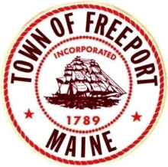
Delia B. Powers
Winslow Memorial Park
& Campground

2019 Season Events Calendar
Gate House/ Help Desk – (207)865-4198
Park Manager-(207)865-9052

Monday, April 1st
^{Online Reservations Begin}
Sunday, May 19th
Campground Opens To Seasonal Campers
Thursday May 23rd
Campground Open To All Campers
Gatehouse Opens Full Time
Saturday, June 15th
Freeport Rotary Close To The Coast Race and Family Fun Day -BBQ, Games, Bouncy House, Beer Tent And live music. Race Starts at 9am with Festivities to Follow

June 15th-23rd
Freeport Free Camping Week #1
(No reservations taken. Residents must register in person after 1pm and immediately set up camp. Unused sites will be re-rented or given to other patrons.)
July 11th - August 29th EVERY THURSDAY
Thursday Evening Concert Series - 6:30 PM
September 7th – Lobsterman Triathlon
September 14th- 29th
Two More Free Weeks of Camping For Freeport Residents
Monday, September 30th
Campground Closes for the Season
(Subject to change based on weather conditions)

