Winslow Memorial Park
& Campground

Neil Lyman – Park Manager-(207)865-9052 – nlyman@freeportmaine.com
Gate House – (207)865-4198
Winslow Memorial Park and Campground
c/o Freeport Town Hall
30 Main St.
Freeport, Maine 04032

SHELTER RENTAL INFORMATION
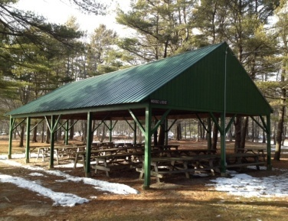
Large Shelter - Moose Lodge

The large shelter provides 12 large picnic tables capable of seating 12 people at each. There is a large charcoal grill, electrical service and a nearby water spigot. This shelter can accommodate up to 150 People.
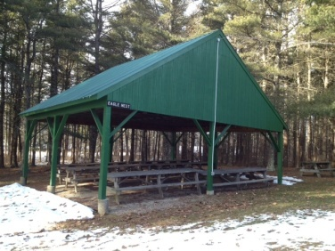

Small Shelter – Eagles Nest
The smaller of our two shelters provides 6 large picnic tables capable of seating 12 people each. This shelter is also equipped with a large charcoal grill, electrical service and water nearby.

Deposit
You are responsible for the cleanliness of the area after you function, there are multiple trash receptacles at each, but we ask that large amounts of trash be brought to the nearby dumpster.
A $50.00 deposit is required to be paid at the gatehouse which will be returned after park personnel have inspected the area. Any tables, trash receptacles, etc.. which are moved by your party must be returned to the original locations. The inability to conform to these rules will result in the loss of your deposit. Winslow Park reserves the right to refuse to admit groups, persons, or caterers whom have had issues conforming to the rules of Winslow Park. Any open fires for lobster bakes or similar events must be cleared with the park manager and may require a permit. This process may take up to two weeks so be sure to inform the Manager or gatehouse staff if you have plans to do so.

Rental Fees
Moose Lodge (Large Shelter)- $150 Non-Resident of Freeport / $125 Freeport Resident – Plus regular per person admission to the park which can be paid individually as people enter at the gatehouse or we would be happy to take a tally and the fee can be paid at the end of the event.

Eagles Nest (Small Shelter)- $100 Non-Resident of Freeport / $75 Freeport Resident – Plus regular per person admission to the park which can be paid individually as people enter at the gatehouse or we would be happy to take a tally and the fee can be paid at the end of the event.

Park admission is $3 for non Freeport residents and $2 for Freeport residents. Park visitors ages 6 and under and 62 and older are free.

The non-refundable rental fee is due upon reservation of the picnic area. Deposits will be taken when you arrive in the form of cash, credit, or check. A credit card must be given in order to do the head count option for visitors. There are absolutely no refunds due to bad weather.

Please Note: Winslow Memorial Park is a recreational area only. The park cannot be used for commercial events. No group is allowed to sell tickets to events held at the park for profit. The gatehouse staff will not collect tickets sold outside the park for any group events. The staff will only take the head count of people for the event or charge individuals as they enter as previously noted. Please be clear on which payment method for entrance you would like to use on your shelter contract.

Alcohol Contract

Winslow Park is a public Park where alcohol is not allowed except on individually rented campsites. However, a group may serve alcoholic beverages provided by an insured caterer with written verification indicating Winslow Park and the Town of Freeport as additionally insured parties is presented to the gatehouse prior to admission the day of the event. Any group without such documentation will not be allowed to consume alcohol inside the park. Additionally each group providing alcohol through their insured caterer MUST also engage in a contract hiring the Freeport Police Department to supply officers on site for the duration of the event in which alcohol is being served. One officer is required for every 100 people or any fraction thereof. THERE ARE NO EXCEPTIONS TO THIS RULE as it is in direct compliance with town ordinance. The attached “Freeport Police Detail Agreement” must be completed and returned directly to the Freeport Police Department at the address listed on the form. Please allow at least thirty days in advance of your event to schedule this detail. ALCOHOLIC BEVERAGES MUST REMAIN WITHIN THE BOUNDRIES OF THE GROUP AREA AND DISORDERLY CONDUCT, COARSE LANGUAGE, INDECENT ACTS, OR BEING UNDER THE INFLUENCE OF ALCOHOL OR CONTROLLED SUBSTANCES WILL RESULT IN THE EVICTION OF THE ENTIRE GROUP WITH THE FORFEITURE OF ALL FEES PAID AND MAY RESULT IN ARREST. (see state public drinking law, title 17, section 2003-a for more information)

If you have any questions regarding rental please contact the gatehouse or the Park manager ( see info on first page). We are happy to try to address any questions, concerns, or special needs your party may have.

