AGENDA
FREEPORT TOWN COUNCIL MEETING #13-23
TOWN COUNCIL CHAMBERS, 30 MAIN STREET, FREEPORT
TUESDAY, JUNE 20, 2023
6:00 PM

ZOOM:
Please click the link below to join the webinar:
https://us02web.zoom.us/j/86469549659
Or One tap mobile :
+13052241968,,86469549659# US
+13092053325,,86469549659# US
Or Telephone:
Dial(for higher quality, dial a number based on your current location):
+1 305 224 1968 US
+1 309 205 3325 US

Webinar ID: 864 6954 9659
International numbers available: https://us02web.zoom.us/u/kdqBDowxqi

FROM: Caroline Pelletier, Town Manager

TO: Councilor Chair Daniel Piltch, 25 Quarry Lane
Council Vice Chair, John Egan, 38 Curtis Road
Councilor Matthew Pillsbury, 36 Todd Brook Rd
Councilor Chip Lawrence, 93 Hunter Road
Councilor Darrel Fournier, 3 Fournier Drive
Councilor Jake Daniele, 264 Pownal Road
Councilor Edward Bradley, 242 Flying Point Road

FIRST ORDER OF BUSINESS: Pledge of Allegiance

SECOND ORDER OF BUSINESS: To waive the reading of the minutes of Meeting #12-23 held on
June 6, 2023 and to accept the minutes as printed.

THIRD ORDER OF BUSINESS: Announcements (15 minutes)

FOURTH ORDER OF BUSINESS: Information Exchange (15 minutes)

FIFTH ORDER OF BUSINESS: Town Manager’s Report (15 minutes)

SIXTH ORDER OF BUSINESS: Public Comment Period – (30 Minutes)
(Non-Agenda Items Only)

SEVENTH ORDER OF BUSINESS: To take action on the following items of business as read by the Council Chairperson:
_____________
ITEM # 119-23 To consider action relative to adopting the June 20, 2023 Consent Agenda.

BE IT ORDERED: That the June 20, 2023 Consent Agenda be adopted.

(Council Chair Piltch) (5 minutes)

ITEM # 120-23 To consider action relative to amending the Town Council schedule to add August 15th, 2023 as the Bustins Island Annual Meeting.

BE IT ORDERED: That the Town Council schedule be amended to add August 15TH, 2023 as the Bustins Island Annual Meeting.

(Town Manager, Caroline Pelletier)(10 minutes)
________________________________________________________________________________

Note: For item 121-23 through item 124-23 the Public Hearing was held on June 6, 2023.

I ITEM # 121-23 To consider action relative to the acceptance of State Funds for fiscal year 2024.
BE IT ORDERED: That the following categories for State Funds be accepted for fiscal year 2024.
1 | Municipal Revenue Sharing
2 | Local Road Assistance
3 | State Aid to Education (including Federal pass-through funds and property
 | pass-through funds and property tax relief
4 | Public Library State Aid per capita
5 | Civil Emergency Funds (Emergency Management Assistance)
6 | Snowmobile Registration Funds
7 | Tree Growth Reimbursement
8 | Veterans Exemption Reimbursement
9 | Business Tax Reimbursement
10 | All other state funds not included in items 1 - 9
______________________________________________________________________________
ITEM # 122-23 To consider action relative to the Operating Budget for Winslow Park for Fiscal Year 2024.
BE IT ORDERED: That $404,865 be approved for the Winslow Park budget from July 1, 2023 to June 30, 2024 and $23,000 be approved for the Harb Cottage budget from July 1, 2023 to June 30, 2024.

ITEM # 123-23 To consider action relative to the adoption of the Fiscal Year 2024 Operating Budget for the Town of Freeport.

BE IT ORDERED: that the following appropriations be made to the several departments for purposes named, that the following revenues estimated be adopted, and that the following amounts to be raised by taxation, said action for fiscal year July 1, 2023 to June 30, 2024 Municipal Budget.
FY 2024 Appropriations
General Government | $ 2,261,195
Protection and Enforcement | $ 3,882,175
Health and Welfare | $ 54,000
Human Service Agencies | $ 39,000
Community Center Building | $ 45,600
Public Works/Solid Waste | $ 2,775,550
Library | $ 612,220
Unclassified | $ 3,131,645
Debt Services-Local | $ 70,300
County & Transit Tax | $ 1,525,142
Bustins Island | $ 300,600
Abatements | $ 25,000
Total Appropriations | $ 14,722,427
FY 2024 Estimated Revenues
Non-Property Tax $ 2,087,500
Intergovernmental $ 2,461,500
Charges for Services $ 388,000
Licenses and Permits $ 527,700
Fines and Forfeitures $ 13,300
Miscellaneous $ 240,000
Total Estimated Revenues $5,718,000

Amount Transferred from Undesignated Funds $ 850,000 Amount to be Raised by Taxation $ 8,154,427
Total Revenues $14,722,427

ITEM # 124-23 BE IT ORDERED: That the following appropriations be made for the capital items/projects listed below, and that the capital budget for FY 2024 be adopted, as presented on the agenda, totaling $3,039,750:
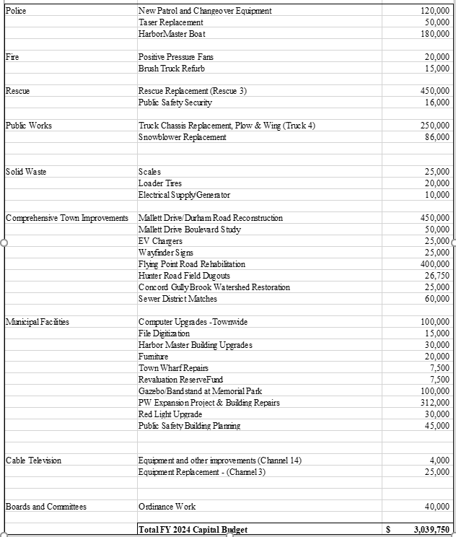

BE IT FURTHER ORDERED: That the following amounts be appropriated from the Reserve Funds to provide for items approved, as presented on the agenda, totaling $3,039,750:

Police Reserves | $ 350,000
Fire Reserves | $ 35,000
Rescue Reserves | $ 466,000
Public Works Reserves | $ 336,000
Solid Waste Reserves | $ 55,000
Public Infrastructure Reserves | $ 1,061,750
General Administration Reserves | $ 122,500
Building Reserves | $ 544,500
Cable Television Reserves | $ 29,000
Other Reserves | $ 40,000
Total FY 2024 Capital Transfer from Reserves: $3,039,750

BE IT FURTHER ORDERED: that the following appropriations be made for the items and projects listed below and that the Destination Freeport TIF budget for FY 2024 be adopted, as presented below, totaling
$324,000:
 | Sidewalks | 45,000
 | Town Hall Site Improvements - Phase II | 50,000
 | Snowblower Replacement | 86,000
 | Freeport Economic Development Corporation | 143,000
 | Total FY 2024 Destination Freeport TIF Budget | 324,000

 | BE IT FURTHER ORDERED: that the following appropriations from ARPA Funding be made for the items and projects listed below, totaling $119,500:
 | Transportation Study | 10,000
 | Meetinghouse Arts Support | 20,000
 | Farmer's Market Support | 1,500
 | Marine Conservation Corp | 18,000
 | Downtown Visioning Project Matches | 40,000
 | Downtown Visioning Engineering Contractor | 30,000
 | Total FY 2024 ARPA Funded Projects | 119,500

(Finance Director, Jessica Maloy)(30 minutes)

_____________________________________________________________________________________
ITEM # 125-23 To consider action relative to a bid award for a new Loader Mounted Snow Blower for the Public Works Department.

BE IT ORDAINED: that the bid for a new Loader Mounted Snow Blower be awarded to Viking Cives of Lewiston Maine in the amount of $171,547.00

Note: $172,000.00 was included in the FY24 Public Works Capital Budget for the purchase of a new Loader Mounted Snow Blower. This will be a saving of $453.00. The funds for this award may not be disbursed until July 1, 2023.

ITEM # 126-23 To consider action relative to a bid award for a new Plow Truck Chassis Tandem.

BE IT ORDAINED: that the bid for a new Plow Truck Chassis Tandem be awarded to Freightliner of Maine of Westbrook, Maine in the amount of $157,736.00.

Note: $250,000.00 was included in the FY24 Public Works Capital Budget for the purchase of a new Plow Truck Chassis Tandem and the transfer of our current plow gear to a new truck. The funds for this award may not be disbursed until July 1, 2023.

The remaining balance of $92,264.00 will be used at a later time to have our current plow gear changed over to our new truck.

_____________________________________________________________________________________

ITEM # 127-23 To consider action relative to a bid award for a new Ambulance.

BE IT ORDAINED: that the bid for a new Ambulance be awarded to Autotronic in the amount of $432,324.00.

Note: The funds for this award may not be dispersed until July 1, 2023.

END OF AGENDA (Estimated time of adjournment 8:30 PM)
 | OUTSTANDING OR UPCOMING  ACTION ITEMS | INITIATED ON | PROPOSED BY | ADDITIONAL INFORMATION
#1 | Review of Town fee schedule this  year | 1/4/2022 | Councilor  Pillsbury | Tasked for April 2023
#2 | Explore new fire rescue substation in District 2 |  | Councilors Fournier &  Bradley

