MINUTES
FREEPORT TOWN COUNCIL MEETING #19-22
TOWN COUNCIL CHAMBERS, 30 MAIN STREET, FREEPORT
TUESDAY, OCTOBER 18, 2022
6:00 PM

Chair Piltch called the meeting to order at 6:05 pm

 | PRESENT | ABSENT | EXCUSED
Councilor Chair Daniel Piltch, 25 Quarry Lane | X
Council Vice Chair John Egan, 38 Curtis Road |  |  | X
Councilor Matthew Pillsbury, 36 Todd Brook Rd | X
Councilor Chip Lawrence, 93 Hunter Road | X
Councilor Darrel Fournier, 3 Fournier Drive | X
Councilor Jake Daniele, 264 Pownal Road | X
Councilor Edward Bradley, 242 Flying Point Road | X

FIRST ORDER OF BUSINESS: Pledge of Allegiance

Everyone stood for the Pledge of Allegiance

SECOND ORDER OF BUSINESS: To waive the reading of the minutes of Meeting #18-22 held on
October 4, 2022 and to accept the minutes as printed.

MOVED AND SECONDED: To waive the reading of the minutes of Meeting # 18-22 held on October 4, 2022 and to accept the minutes as printed. VOTE: (Fournier & Piltch)(6-Ayes)(1- Excused-Egan)

THIRD ORDER OF BUSINESS: Announcements (15 minutes)

Meeting House Arts is showing Our Town and it is spectacular. Everyone is encouraged to attend.

FOURTH ORDER OF BUSINE SS: Information Exchange (15 minutes)

Councilor Bradley attend the Sewer District meeting last night. He came away thinking that it is time for those working on Downtown Revisioning and the Sewer District to get together again. There are positive things going on in the Sewer District, but they aren’t going to solve the sewer problem for this town, or downtown or clammers or this harbor or anything that the Sewer District serves. We have Sewer as one of the items identified on the Revision priorities list. This is a good time to work together. There is money around that might apply to it and a lot of ideas of how to fund sewer improvements. He is proposing that they put on an upcoming Council agenda to discuss how as a Council they want to relate to and collaborate with the Sewer board. The Sewer Dept. Superintendent feels as though he’s on an island down there. Brett Richardson is working on earmarks we didn’t get and Lee Arris is working on Rural Development grants which he thinks has promise but there are other ways to fund things. As a Council and a Sewer board we have to decide to do it together and not leave the Sewer board hanging to figure it all out. There are issues inherent in that discussion, both historical memory and future responsibility. Chair Piltch is also on board with collaboration. Councilor Bradley proposed by consensus saying this is a good idea we would like to pursue with the Sewer Dept. and then choose a few people to do it with them. Councilor Bradley was under the impression that Brett Richardson (FEDC) was working with the Sewer Dept. and the Town after their first meeting, but they’re not. Brett Richardson has ideas and supports FEDC being involved. They want to see the Town direct the process. If we are ready to do this he would suggest a couple people volunteer to work with Leland Arris (Sewer Dept.) to come up with a method or approach to collaboration that is more detailed. Brett also has ideas about funding if he knew the town wanted to do it and the Sewer Dept is in the final stages of getting a response to the Rural Development Grant for $14.7 million which doesn’t come close to covering the costs and they still don’t know the amount of the grant award. You have to fund the gap. The fees can’t cover the cost of $600,000 a year. Connection fees for downtown, which we were concerned about, can’t cover it. Councilor Lawrence would be interested in working with this group. Councilor Fournier talked about the Sewer Districts autonomy. He thinks we should have a frank discussion about the issues past and present and would help with this group.

Councilor Pillsbury: Is the ask to get engaged in response to them trying to fundraise for their operational needs, because they had a comprehensive plan, but it wasn’t an expansion of the district. It was going to be keeping things going for the next 20 years. Is this a discussion of how the Sewer District can better integrate into the visioning of the downtown or is it how to raise the money to meet their operational needs at this moment? It is both. They have significant capital needs to continue to operate in the near future. The needs for remedy and redress are increasing exponentially so we have to do this. They need to fund the gap, but the Council has recognized connection fees as a concern for revisioning and that’s part of how they raise money. The Sewer Department has the money for annual costs of running the plant, what they don’t have is the money to close the gap in the 14.7 million dollars which is also near-term revision, modification, improvement salvage of the plant. Beyond that there are repairs that may make it 5 years which could go at any time. Councilor Bradley thinks we ought to seriously consider being partners in this rather than critics. The Sewer District. has previously thought of us as oversight without attachment. In previous meetings with the District they were hyper focused on their immediate needs and getting grant funding for it. The only thing that came from the meetings was that FEDC would help them apply for grants or maybe we could get earmarks for them, but they didn’t seem ready for the second part of that conversation. The Sewer District agrees it’s time to figure out how to solve the problem.

Councilor Fournier: What about a connection with the Brunswick Sewer District? That’s a pricey look that would happen, however, when we look at our housing needs coming in the future, we are going to run out of room down there. He is excited about looking at alternatives.

Councilor Fournier and Councilor Lawrence agreed to be the two Councilors that work with the Sewer District.

The Public Safety Open House was a great success.

The Downtown Workshop a week ago had approximately 120 people attend. The meeting focused on the 20 goals/projects. They will bring a shortlist back to the Council for discussion at the next meeting. We can vote on what the list is that we move forward as our starting point next year. There is no budgeting yet.

FIFTH ORDER OF BUSINESS: Town Manager’s Report (15 minutes)

This week we got notification from Maine Municipal that our Annual Report was awarded the first place for our size population in the State.

Later this week we will be reposting the revised Zoning Administrator position. The position will be for a Land Use Specialist. We did revision the position to divide out the Codes and Building inspection things with the Land Use (i.e. Subdivision and Shoreland) and bifurcate that. This person will work with both Planning and Codes but they are focusing on two different buckets of Planning and Codes.

SIXTH ORDER OF BUSINESS: Public Comment Period – (30 Minutes)
(Non-Agenda Items Only)

Joyce Veilleux: Chair of the Police Advisory Committee-She wants a feel from the Councilors. The Committee is doing a survey of where residents would like to see our Police Department 5-10 years down the road i.e. size, new types of positions etc. Once ready, she is asking for assistance with distribution utilizing the town’s resources such as the Bulletin, website and email distribution lists. The survey will be no more than 5 questions. It was suggested to include it in the annual donations letter that is mailed in December.

Scott Poulin: Has 35 years of municipal and school finance and wants to recognize the hard work that went into the Finance award and wanted to thank them for their budgeting processes.

SEVENTH ORDER OF BUSINESS: To take action on the following items of business as read by the Council Chairperson:
_____________
ITEM # 195-22 To consider action relative to adopting the October 18, 2022 Consent Agenda.

BE IT ORDERED: That the October 18, 2022 Consent Agenda be adopted. (Lawrence & Daniele) VOTE: (6-Ayes)(0-Nays)(1-Excused- Egan)

(Council Chair Piltch) (5 minutes)
____________________________________________________________________________________
ITEM # 196-22 To consider action relative to proposed amendments to Section 202. D. Non-Conforming Lots of Record of Chapter 21 – Town of Freeport Zoning Ordinance. PUBLIC HEARING

Town Planner: We have been working on cleaning up our Ordinances. We did clean up to the non-Conforming section regarding structures. This has come up over the years. We have people who have legally non-conforming lots which means their lot existed before Zoning, not that they did something to make it illegal. People with these lots are stuck in the place, they were before Zoning existed and they can’t alter their lots. An example of this situation was shared. What is before the Council tonight is language that is (in the Zoning Ordinance, outside the Shoreland Zone), if you have a legally nonconforming lot, you can alter that lot as long as you don’t make it non-conforming in any other way and it wouldn’t lose the non-conforming status. At the suggestion of the Department of Environmental Protection (DEP), we did add in there that it does not apply to lots in the Shoreland Zone because they have their own provisions in the Shoreland Zoning Ordinance.

Councilor Fournier asked how we fix the Shoreland. Any changes we make to the Shoreland Zoning have to meet the minimum requirements of the Maine DEP and any changes also have to be reviewed and approved by them. The new language we just adopted meets the minimum, but DEP does not have language that allows the municipality to include this provision in the Shoreland Zone. He asked what our options are to go to the DEP and say that we want people treated equally in our community and across the State. The Planner stated that we have worked with the DEP on other cases and we have been able to see changes. We did run this by DEP and they liked that we were clear. We wanted to make people understand that it does not apply in the stand-alone Ordinance. Our DEP language comes straight out of State statute, it would be a larger issue beyond us. We could reach out to our Representative. Councilor Fournier would like to see us push forward with trying to find a solution to this. We have more lots this applies to than we realize.

This allows people to increase their lot size. They can also reduce it back to the former size but not lower. They had not added a provision to lower the acreage back to the initial size and can get legal guidance if we want to add that. They discussed whether allowing this would be productive and why we should or shouldn’t allow it.

MOTION: To open the Public Hearing (Pillsbury & Daniele) VOTE: (6-Ayes)(0-Nays)(1-Excused-Egan)

The Planner wants to amend the ordinance to add three words. On the cover page where it reads “alteration to non-conforming lots-a non-conforming lot legally existing as of the effective date of the” we want to add the words “adoption or amendment”. That way it’s not just the lots that existed when we adopted the ordinance but it’s other people who could have become legally non-conforming due to a change we made in the Zoning. It would include anyone we have made legally non-conforming since 1976. Any future zoning amendments to the ordinance that made them non-conforming would be covered by this amendment.

Scott Poulin spoke about his specific non-conforming lot situation that would be rectified by this amendment and would allow him to get a permit and move his garage. He created a new non-conforming lot by adding a piece to his property that then prevented him from taking action on his property.

Joyce Veilleux: Has been non-conforming for three generations. It makes no sense that people on the shore can’t do the same thing. They ought to be able to increase their lot size and not be penalized for it. The DEP language does not prohibit this, it doesn’t allow it either. Let’s be the first, put it in the ordinance and send it to the DEP. People in the Shoreland don’t qualify for what the rest of the public does. Let’s approve this but continue to work on it.

Carter Becker: Thinks this is good work. Let’s continue it for the waterfront also. If we strike the one line that reads “the provisions shall not apply” he believes we would be sending it to DEP for a 45-day approval or denial. If they don’t object, we get our ordinance. That would solve our waterfront problem. Send it up to DEP and the worst that happens is they say to put the wording back in.

Bill Creighton: Echoes Mr. Becker’s comments.

Town Planner: if we want to make the change in the Shoreland, we have to amend the Shoreland Zoning Ordinance. We have consulted with DEP and we have gotten guidance that they agree this would conflict with what is in the Shoreland Zoning Ordinance and she would not want to amend it on the fly. If we want to amend it, we would amend the non-conforming section of the Shoreland Zoning Ordinance. If we take action as written, she will email the language to DEP and see if we can get an advisory opinion in writing if we can put it in the Shoreland Zoning Ordinance. If we can convince them, which she doesn’t think we can, we would amend both ordinances at the same time to be clear and stay consistent.

Councilor Bradley: The sentence we are being asked to remove did not receive or require DEP approval because it’s in the Zoning Ordinance and we’re exempting it from the Shoreland Zone. If we strike that we will need an advisory opinion and they will have 45 days if we are making changes that could essentially affect the Shoreland Zoning. This way as written there is no question. We made the Shoreland a stand-alone ordinance so every time we make a change to the Zoning Ordinance it doesn’t have to go to the DEP. Anything that could potentially affect the Shoreland, the interpretation is that this would conflict with the Shoreland Ordinance, but it’s not going to be clear and it’s going to raise flags and slow down Mr. Poulin. DEP has taken the full 45 days in the past.

Town Manager: The reason the wording has been included even though redundant is to clarify to DEP that this is not intended to modify Shoreland, so they have zero confusion that they are not reviewing this. DEP guidance is that you can’t do this amendment in the Shoreland zone, but we will go back and get it in writing and give them the language and see what are steps are to advocate. If we take the language out there should be no confusion to the public that it changes anything in the Shoreland zone. DEP may or may not comment or ask us to put it back in. The Shoreland zone prohibits the proposed changes from applying in the Shoreland zone until we change the Shoreland zone. The Attorney General has advised the DEP that state law will not allow the modification of the lot of record definition in shoreland ordinances, in general, across the State in conformance with State laws.

Chair Piltch: If taking this language out doesn’t clearly allow this to apply to Shoreland Zoning, because we have a separate ordinance we would need to amend in that case, assuming DEP approves so taking this out doesn’t seem like it has an effect immediately. Taking it out may trigger DEP to say they may want to review it because it may not be clear now if you intended it to apply to Shoreland zones. This would potentially delay people such as Mr. Poulin for up to 45 days.

Councilor Fournier: Doesn’t want DEP to come anywhere near the zoning because it is the business of the Town of Freeport. By adding this in does it raise a red flag. If we take it out, DEP doesn’t get involved he would be in favor of that. Ms. Pelletier sees it differently. If we take it out and someone raises a concern then we get this reviewed again. If it says “does not apply to Shoreland zone” it’s not going to the Commissioner’s office because we were perfectly clear. The Planning Board did not talk about this in the Shoreland Zone, it was clearly mentioned that it wasn’t going to apply there.

Andrew Arsenault: Planning Board-Would hate to delay Mr. Poulin any more. Supports the proposed language that was approved at the Planning Board including the Planners suggested amendment.

Councilor Fournier: Does MMA have the gumption to propose a bill through the LPC to address the problems in the Shoreland. Mr. Joseph relayed that there is great reluctance to address shoreland zoning at the legislative level.

MOTION: To amend the language to add “adoption or amendment” (Bradley & Lawrence) VOTE: (6-Ayes)(0-Nays)(1-Excused-Egan)

MOTION: To close the Public Hearing (Pillsbury & Lawrence) VOTE: (6- Ayes)(0-Nays)(1-Excused-Egan)

BE IT ORDERED: That proposed amendments to Section 202. D. Non- Conforming Lots of Record of Chapter 21 – Town of Freeport Zoning Ordinance as amended be approved. (Pillsbury & Fournier) VOTE: (6-Ayes)(0-Nays)(1-Excused -Egan)

Note: The amendment would allow for the alteration of legally existing non-confirming lots of record provided that the alteration does not create any new non-conformity.

(Town Planner, Caroline Pelletier)(30 minutes)
__________________________________________________________________________________
ITEM # 197-22 To consider action relative to a Tax Abatement for parcel 821-63-C-0

There are four tax years in question. We are allowed by State law to go back three years and correct. This lot was double billed for many years for an outbuilding. The Assessor’s recommendation is to refund the residents overpayment. This went on for more than three years, but we are only allowed to send a tax abatement refund for the past three years.

If the Council wants to appropriate outside of that process, it’s no different than appropriating money for a bridge, it’s a political matter. It would be nice to know how long this occurred for. Keep in mind that we want to be careful setting precedent with tax abatements that could involve significant funds.

Councilor Fournier: In fairness to a tax payer who has overpaid for many years, he feels we should make him whole.

Councilor Lawrence reminded that a future Council would not be bound to anything if this Council rebates overpayments outside the 3 years. He supports going further back. The manager will do some research and we can address during the budget process as funds would need to be appropriated. We could do this action tonight and look at it more then. We will work with the assessor and review the digital records (10-20 years back).

BE IT ORDERED: That a Tax Abatement for parcel 821-63-C-0 in the amount of $596.64 be approved.
(Fournier & Lawrence) VOTE: (6-Ayes)(0-Nays)(1-Excused- Egan)

Note: The Assessor has determined that this parcel was erroneously assessed and taxed.

(Town Manager, Peter Joseph)(10 minutes)
____________________________________________________________________________________
ITEM # 198-22 To consider action relative to an ARPA funding award for Freeport Community Services in the amount of $112,500.

Town Manager: The Council had previously asked Sarah Lundin, Executive Director of Freeport Community Services for more information on potential increased costs that FCS is experiencing and potential ways the funding could be used. We have a detailed memo from FCS on their additional costs. Capital items were included but are not a double ask. There are draft numbers in the memo. $112,500 is rounding up for the difference for the 30-hour position, the programming and resources, mostly for the Fuel Fund, but a few other items including the food pantry and similar. There were other additional ongoing Capital expenses that were included in the memo from last time.

Councilor Pillsbury: Is of the belief that the ARPA funds are to be used to benefit our most disadvantaged citizens during Covid and the ongoing impacts. He supports a third of the remaining ARPA funds be designated for FCS. He would like to give them a buffer and double the amount.

Councilor Fournier: The 30-hour a week position was supposed to be a temporary position for their operating budget until June. He hopes this doesn’t show up as another position that needs to be added. He also questions whether that is enough money for fuel.

Town Manager: The Town is anticipating a one-two year need based on the numbers we are seeing. He’s not convinced it will be permanent. The idea is that if it shows up next year, it will be part of the budget discussion. That’s why it was left out of the recommendation amount here. His understanding was that if we needed this position going forward after July 1 of this year or next year, the Council would be deliberating on it during the budget process in a few months.

Remaining ARPA funds are approximately $525,000.
Councilor Bradley: Did calculations that support this funding would provide 60 gallons per each of the 100 people twice per season so he supports adding to the number. We need to keep in mind that the waiting period for applications is months long before their intake appointment. He would be comfortable assigning more money to a quantifiable need such as heating oil.

Sarah Lundin: FCS has approximately $45,000 set aside for fuel assistance this year to help about 40 households throughout the winter. She has provided a one-year snapshot to the Council. They are looking at needs and constantly reassessing. They have the Freeze out in February and there are also grant opportunities that will be back up plans.

Councilor Daniele: The transfer on funds from the Town to FCS occurs in a 2-4-week period and are instantly available for reallocation. We could approve this tonight and we can get a lay of the land. He would hate to do an extra $100,000 then have a catastrophe in 2-3 weeks and we realize we erred. He supports approving this tonight and keeping a good dialogue going about FCS needs. Councilor Lawrence supports additional funding also. The $87,250 for Essential Programming and Resources may be spent in any of the ways outlined in the memo. FCS’s breakdown is to support the requested number. The Town’s appropriation will be general financial support and they use it where necessary (i.e. fuel assistance or emergency disconnect for example).

Jessica Maloy explained ARPA funding requirements. When accepted the funds we did under the premise of loss of revenue and allowed us to use it for general governmental operations. When you are using it for a specifically designed purpose that is explicitly stated within the regulations you then have to follow suit of those regulations. Anything they use the money for would have to be reported in the same fashion as if we were to use it on our purposes for specific purposes. She outlined the reporting requirements that we must follow. The uses that are outlined in the FCS memo are governmental uses that we already provide some contribution to FCS for so it’s just enlarging our contribution. It’s not just money turned over that they can use freely, FCS is going to have to report and monitor and respond to us, because we have to report to the Federal Government. If it doesn’t meet the requirements and they have spent the money, then the town is on the hook for it. This will be inline with FCS current report. We can allocate to General Assistance then they will put on that aspect of the program and there are no additional reporting requirements.

Councilor Bradley spoke the remaining ARPA funds and his support of doubling the requested amount. Councilor Lawrence proposed amending the amount to $200,000.

Councilor Daniele: supports funding FCS with the requested amount. They can come back for additional funding if necessary.

We have until 2024 to appropriate the ARPA funds and until 2026 to expend them. The backpack program is run independently, separate from the RSU.

Chair Piltch recapped what has been discussed so far and would like to approve the request as written. He suggested holding a certain amount of ARPA funds in reserve for 6 months.

BE IT ORDERED: That an ARPA funding award for Freeport Community Services in the amount of $112,500 be approved.

BE IT FURTHER ORDERED: -That another $87,500 be held in reserve for 6 months that will be returned to the General ARPA fund if not used. (Lawrence & Fournier) VOTE: (6-Ayes)(0-Nays)(1-Excused-Egan)

(Town Manager, Peter Joseph)(15 minutes)
_____________________________________________________________________________________
OTHER BUSINESS:
- Voting Update (Town Clerk, Christine Wolfe)(10 minutes)

We have been absentee voting last week and had 695 requests before we even started issuing ballots. Thanks to Councilor Daniele tonight we are at 1,157 ballots issued in just one week. We are on track to match our 2020 record of almost 5,000 absentee ballots. Voters have until the close of business of Thursday, November 3 to order their absentee ballots without special circumstances. They have three more weeks from tonight we will be closing the polls. The ways that absentee ballots can be requested has not changed. You can vote in person, call the clerks, order them at Maine.gov or do written application. The ways to return the ballot were outlined.

New this year voters may go to Maine.gov and not only order their absentee ballot, you can now track every aspect of your ballots path. In October of last year, we started providing the Accessible Absentee Voting feature that allows voters with print disabilities to use a standard screen reader software that allows them to vote from home. The other new item is Automatic Voter Registration at the DMV. When you do a driver’s license you can register to vote at the DMV. This should reduce voter registration at the polls. The other new feature is Vote411.org. One of our biggest issues we have is that voter’s come to us for candidate information that we are unable to provide due to voting restrictions. Vote411 reaches out to candidates, State and local, to submit a biographies or answer questions. On the town website we have made links to everything discussed here tonight. Voting location is still the High School Gymnasium. Ballots have to be returned to the Clerk by 8 pm Election night.

Preregistration is available to 16 year olds who may vote in a Primary at 17 and will automatically become registered at 18. They can do this when they get their licenses at the DMV.

The entrance for voting will remain the main High School entrance. The back entrance to the gymnasium was used just during the Covid mask restriction period for the school.

- FY22 Audit Presentation (Finance Director, Jessica Maloy) (20 minutes)

Jennifer Conners, from Runyon Kersteen Ouellette presented the Financial Overview for FY22 Audit. They will be providing the finalized reports once they are complete. The financial statements did receive an unmodified opinion which means they are materially correct in accordance with generally accepted accounting principles, so that’s a clean opinion on the financial statements. We are also required to do some testing under government auditing standards. Under those requirements they test internal controls as they relate to financial reporting. Under those testing requirements they had no material weaknesses (highest level of finding) and no significant deficiencies. A very clean audit. Ms. Conners went on to describe and explain the findings in the following presentation. Ms. Maloy explained how she manages the unassigned fund balance. It is our policy to keep 1.5 months of all expenses in unassigned reserve. In January, she will come back to the Council with the amount in unassigned fund balance for decision about how we distribute. Last year, we used some to offset taxes and the remainder went into reserves. She thinks something similar will occur this year. The GFO best practice is two months of expenses in reserve. The benefits of a well-funded reserve were discussed. We have been growing our Reserves, but looking out at the 5-20 year expenditures we have large items on the horizon. The last couple of years we have not had investment reserve growth and we will not have a sustainable reserve system if this continues. The money we invest, we don’t make money on. We’ve been wanting to address this for a couple of years. Councilor Bradley is less concerned about large expenses out 20 years and a small reserve now because he’s seen that small reserve grow every year to the detriment of the taxpayer who is funding that reserve balance and seeing no use of those funds other than something we want in 20 years.

At the next meeting we will be talking about the 20 downtown projects and how we’re going to fund them. The options for the fund balance are that we can return it to the taxpayers through tax rate reduction, we could transfer to Reserves or we can use it for an unbudgeted or unanticipated expense.
SUMMARY OF AUDIT RESULTS
- Timing of the Audit

Pre-audit May 25, 2022
  - Audit week of August 1, 2022

Report Required by Government Auditing Standards (GAS)
'
  - No material weaknesses
  - No significant deficiencies
- Financial Statement Opinion-Unmodified

TOWN OF FREEPORT
General Fund - Fund Balance

$10,000,000
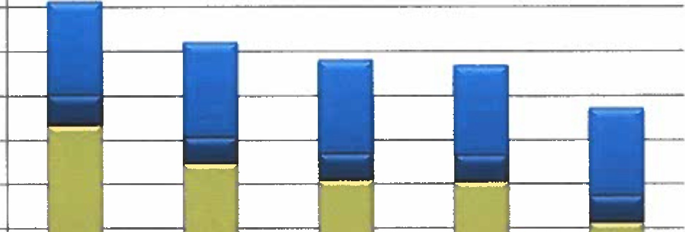
$9,000,000
$8,000,000
$7,000,000
$6,000,000
$5,000,000
$4,000,000
2022 |  |  | 2021 |  |  | 2020 |  |  | 2019 |  |  | 2018
$16,233 |  |  | $14,896 |  |  | $11,439 |  |  | $10,100 |  |  | $13,132
$2,086,523 |  |  | $2,120,158 |  |  | $2,105,510 |  |  | $2,020,529 |  |  | $1,990,038
$675,000 |  |  | $600,000 |  |  | $600,000 |  |  | $600,000 |  |  | $600,000
$6,355,090 |  |  | $5,472,919 |  |  | $5,096,893 |  |  | $5,057,027 |  |  | $4,128,874

$3,000,000
$2,000,000
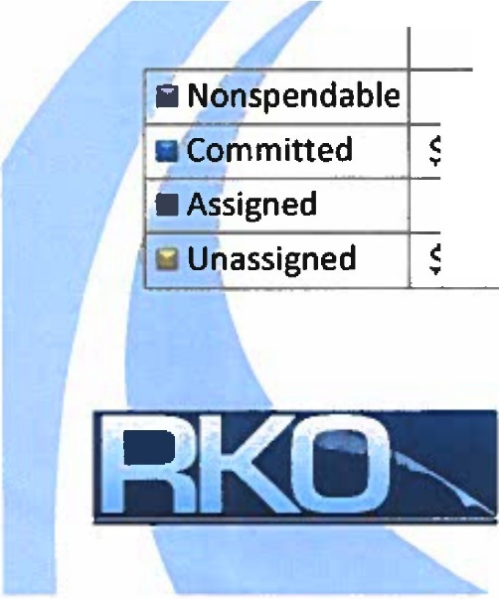
$1,000,000
$-
Committed
Unassigned

Observations:

Committed fund balance, which represents amounts set aside for tax stabilization, future employee benefits, and reserves, has increased 5% from 2018 to 2022.

- Assigned fund balance, which represents the budgeted use of fund balance for the next fiscal year, increased $75k after remaining the same for the four prior fiscal years.

- Unassigned fund balance has increased 54% from 2018 to 2022.

- Total fund balance increased

$955,612, or 12%, from FY 2021.

- Total fund balance has increased

$2,400,802 since FY 2018, or 36%.

TOWN OF FREEPORT
General Fund Revenues
Budget I Actual Variance
Taxes $28,717,065 29,449,598 732,533

Observations:
  - Taxes were higher than budgeted, as the actual property tax revenues

and
Licenses and Permits [- 296,400 |  | JL | 355,686 | II | 59,286 | include overlay, net of abatements,  excise taxes, which exceeded the budget by $234K.
IntergovernmentaI | 1,878,800 |  | 2,351,790 |  | 472,990
•Intergovernmental revenues were

level.
Charges for Services | _JL 208,500 JL 282,855 JL 74,355 |  |  |  | higher than budgeted as state revenue  sharing was $362K higher than
Fees and Fines | 29,800 |  | 28,063 | (1,737) | budgeted due to changes at the state
Unclassified |  |  |  | 42,745

[ 48,60 | 0 [ 91,345 ][

    - Charges for services were higher than budgeted, mainly due to recycling center revenues that were higher than
Investment Earnings | 15,000 | 25,299 |  | i 10,299
Total Revenues | $31,194,165 | 32,584,636 |  | 1,390,471
Use of Fund Balance | 600,000 |  |  | (600,000)
Transfers In | 480,000 | 450.000 |  | (30,000)
Total Revenues and Other Financing Sources | $ 32,274,165 | 33,034,636 |  | 760,471

I anticipated.

•Total revenues were higher than anticipated by 4%.

TOWN OF FREEPORT
General Fund Expenditures
 | Budget | Actual | Variance
General Government | $2,037,340 | 1,890,137 | 147,203
Public Safety | 3,243,285 | 3,147,346 | 95,939
Public Works | 2,449,885 | 2,143,859 | 306,026
Community Services | 867,470 | 786,179 | 81,291
Education | 19,919,982 | 19,919,982
Insurance and Benefits | 2,060,600 | 1,901,944 | 158,656
County and Transit Tax | 1,368,958 | 1,368,958
Unclassified | 292,050 | 284,649 | 7,401
Debt Service | 34,595 | 38,269 | (3,674)
Total Expenditures | $ 32,274,165 | 31,481,322 | 792,843
Transfers Out |  | 600,000 | (600,000)
Total Expenditures and  Other Financing Uses | $ 32,274,165 | 32,081,322 | 192,843

Observations:

- General Government expenditures were under as some budgeted positions were unfilled.

- Public Safety expenditures were under budget as budgeted positions were unfilled and decreased use of reserve officers.

- Public works expenditures were under budget as less road work was completed due to staff shortages. In addition, there were budgeted positions that were unfilled.

- Community services expenditures were under budget due to budgeted positions remaining unfilled . In addition, costs related to the Amtrak station were lower than anticipated.

- Insurance and Benefits expenditures were under budget due to staffing changes and enrollment elections.

TOWN OF FREEPORT
UNASSIGNED FUND BALANCE AS A PERCENTAGE OF BUDGET

25.00%

20.00%

15.00%

10.00%

5.00%

0.00%
 | 2018 | 2019 | 2020 | 2021 | 2022
Percentage | 14.67% | 17.97% | 16.75% | 17.70% | 19.69%

Observations:
  - Unassigned fund balance increased as a percentage of budget over FY 2021.
  - The Town's fund balance policy target is 1 ½ months of the budget, or approximately 12.5%, with an additional 5% of the target allowed for a maximum fund balance.
  - Compared to the FY 2023 budget, the FY 2022 unassigned fund balance exceeds the maximum by approximately $2 million.

6

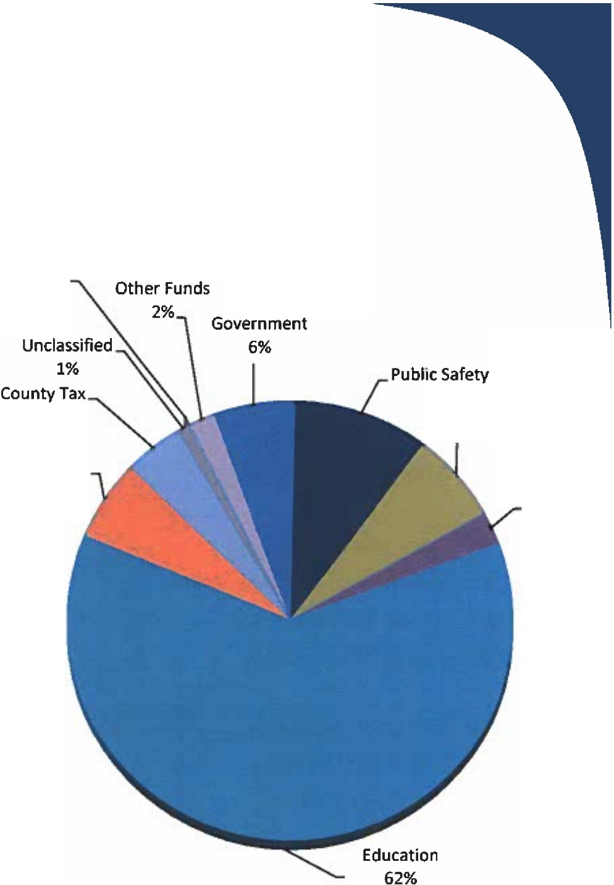
TOWN OF FREE PORT
2022
Debt Service
0%
Transfers to
General
4%
Insurance and
Fringe Benefits 6%
10% Public Works
7%
Community Services
2%
Expenditures (Pie Chart)
2021

Debt Service 0%
Transfers to Other Funds 4%

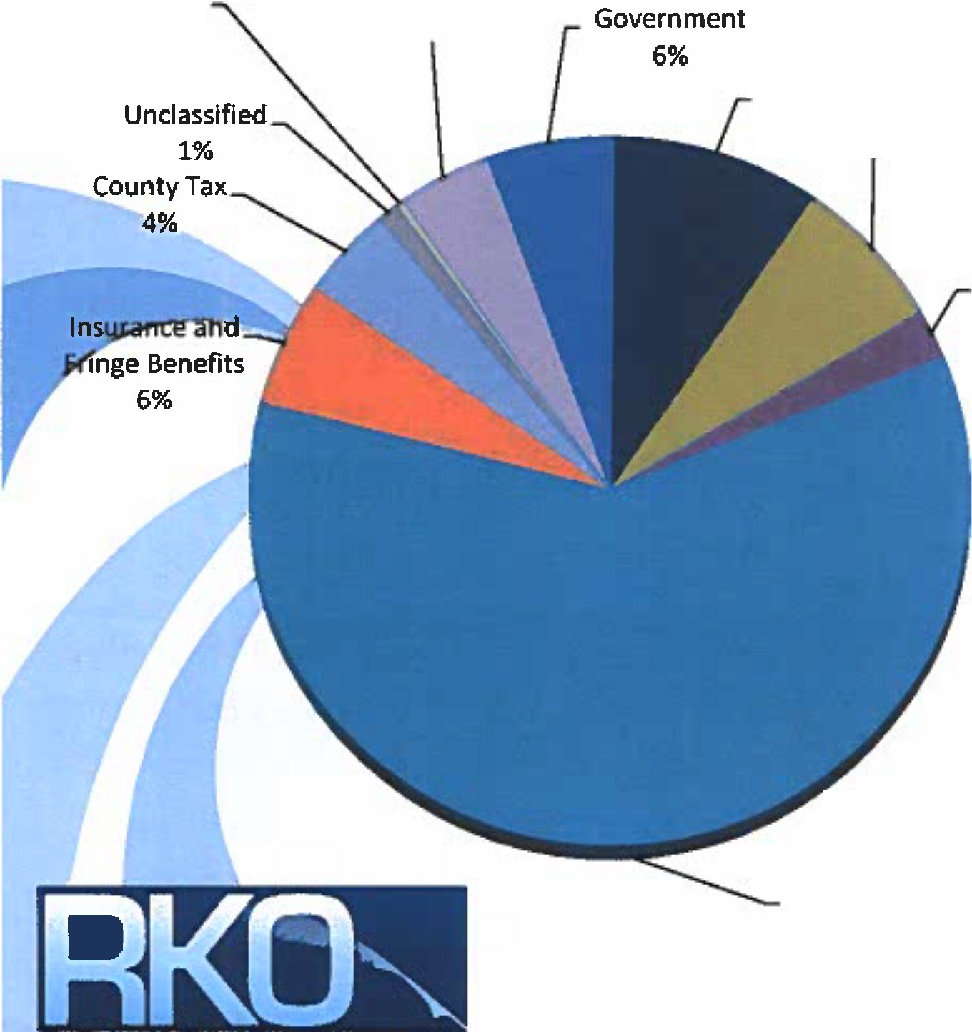
General

Public Safety
10% Public Works
7%
Community Services 2%

Education 60%

Runyon Kersteen Ouellette

TOWN OF FREEPORT
TOWN RESERVES

6/30/2022 6/30/2021 Change

Police Department L 215,886 I 194,160 21,726

Fire Department 974,715 903,416 71,299
--r-
- Rescue reserve decreased due to spending on communications upgrade.

Public Works reserve

Rescue Department _L 73,223
Public Works 421,717
247,498 - {174,275)
255,999 165,718
I
I
--------,i:---

increased due to a transfer in for the dump truck replacement.
Comprehensive improvement reserve
Increased due to the bond proceeds for the DOT bridge work

Municipal Buildings reserve: increased due to transfers in various projects

Capital Projects reserves-decreased due to transfers to the other reserves.

Recycling
Comprehensive
Improvement
:i
JL
Municipal Buildings
Boards and Committees
Capital Projects
Total Capital Reserves

General Fund Total Reserves

310,424 ·1 271,686 38,738

2,350,200 1,818,070 532,130
I
r--
I
L
.
1,123,587 II 729,484 II 370,103

243,338 301,517 {58,179)
r 6,287,646 71 6,9,639 71 (670,993)
$12,000,736 | $11,680,469 | I  $320,267 | for various projects.
608,401 | 636,842 | (28,441 )

$12,609,137 $12,317,311 $291,826

- Comprehensive improvement reserve increased due to the bond proceeds for the DOT bridge work.

Municipal Buildings reserve

increased due to transfers in

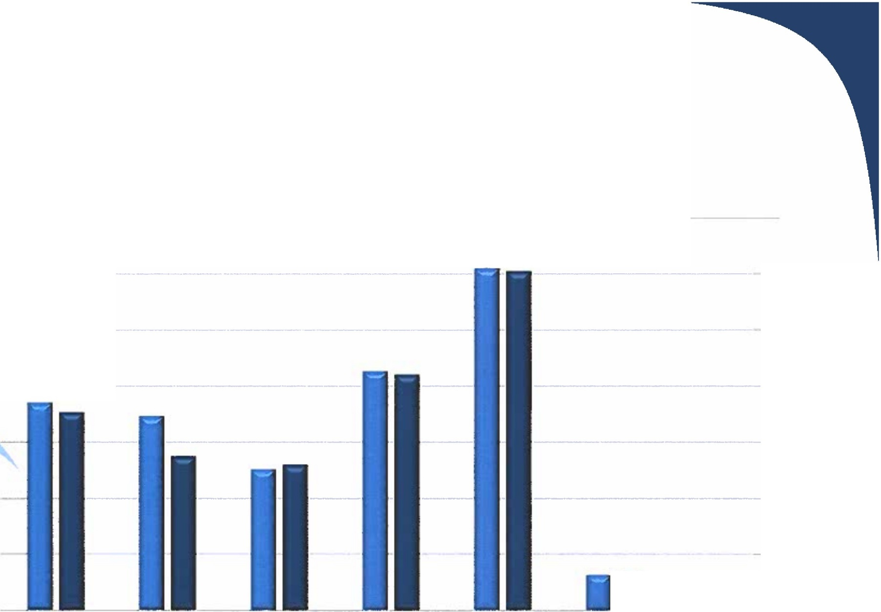
TOWN OF FREEPORT

$1,400,000

$1,200,000

$1,000,000 - --

$ 800,000 - - - - -

$600,000

$400,000
OTHER TOWN FUNDS

$200,000

$-
I
Winslow Park TIF Funds Bartol Building Tower lease Town Grants Leon Gorman

(200,000)

2022 ■ 2021

3. Competitive Bid Policy Discussion (Town Manager, Peter Joseph)(10 minutes)

The current policy has 3 sentences on competitive bids and 1 sentence on competitive quotes. It basically sets the dollar amounts and what we’re supposed to do. We have a new policy to propose that has more details including meat about conflict of interest. Purchases under $10,000 will be done on the open market as long as the cost is considered reasonable. Good services between $10-$25,000 would be by written quotation. Purchases over $25,000 would be by sealed bid. Any purchase over $100,000 needs to be approved by ordinance of the Town Council. Detail on waiver of bid process and what might trigger that is covered in the new proposed policy. They still need to better define single source item.
Emergency purchases-the policy outlines a process that truly defines what an emergency is. The Town Manager must notify the Council immediately if he does something outside the process. There have only been 3 or 4 emergency purchases that have happened in 10 years and were $10,000 or less.

The policy also addresses combined purchases and Federal Procurement which is the Finance Directors language and specialty to make sure we are complying with current standards. It may need to be changed as Federal guidelines change. Could we just reference the Federal guidelines, so we don’t have to change it every time and say “see the section”. Or say “unless superseded by more recent guidelines” or something to that effect.

Implementation and roll out: the one more onerous thing that’s going to be on department heads is a summary if how they complied with the purchasing process. When the department does the process for purchases, they will have to document the steps in the process. This is formalizing the process that we’ve been doing. The form will be made available and will substitute the memo they submit now. We do not use purchase orders.

Chair Piltch: For clarification we should define “immediate family member” and “potential conflicts of interest”. The Single Source thing needs more work along with “emergency circumstances” which needs a definition. He is also confused on the middle category of $10,000 to $25,000 where it says the purchase can be made on the open market without getting competitive bids as long as the cost is reasonable. The required procedure would be to get bids from three qualified sources. The Manager suggested it reading “the required procedures to be solicited and evaluated. You want to go out and get three bids, but the issue is when we don’t get three bids. They discussed examples of conflict of interest problems.

We do not have to accept the lowest bid, but we have to justify why we didn’t and went with the most qualified bidder. Jessica will edit the draft policy and return it to Council.

4. Lodging Discussion (Town Manager, Peter Joseph)(30 minutes)

Starting in 2019, we have seen a large change in how our larger motels/lodging units are being utilized. Shelter overflow housing is a significant portion of this. There is a change in the demographics of who hotels rent to and use as semi-permanent housing for groups such as asylum seekers and refugee new Mainers. It’s a shift in the demographic. The concern is driven mostly by the impact to town services. There is a drastic change in the nature due to a small segment of those populations that we talked about creating an overload on police, fire, emergency services and FCS who contracts for our General Assistance. These groups are in need and it is our responsibility to bear some of that need. Another huge shift happened when Portland during the pandemic changed their policies on who they were going to be funding and shut down shelters. This is a dramatic shift for them to do the GA minimums. That moved a lot of people out. There are more people than beds in the area. The real shift has been to using hotels for either voucher programs or longer term stays regardless of the group, it’s a change in capacity and occupancy patterns we are used to. Where it’s an issue is because of the ratio of Freeport having a higher population of hotels per capita. We are small town budget and population base, with a large tourist base. Freeport is much higher than other municipalities in Maine. For example, Yarmouth has the same population, but they have 40 rooms being utilized and Freeport has hundreds. We’re impacted more on a per capital and town operation basis because of that and that is why we want to start the conversation. We don’t have a proposal or identification of the issues as it’s several different factors being combined at the same time.

Police Chief Goodman: This has been a hot topic item in the Portland and surrounding area. They have been called to address the chronic homelessness that Portland had the lion’s share of and the closing of their largest shelter has sent people out into the surrounding areas. We have seen a marked increase in the number of calls for service our officers have been engaging in. Mental health, drug issues, violent crime and regular crime, these are all issues that have increased especially along the Route One corridor where we have a high concentration of these hotel/motel rooms. We are in a unique position, there is not another community our size in southern Maine that has the amount of hotel rooms that we have that is dealing with a similar problem. He explained there are 2-3 officers working at night that go home over the shift. We are staffed to handle typical Freeport calls over that time, but when you start throwing in dozens and dozens of calls every week involving people who are in a high need category, it quickly starts to overwhelm the officers that are working. They have been attending meetings and trying to get on the same page with this issue. It’s not unique to Freeport. It is unique in that we are one of the smallest communities that is taking such a big hit. He started talking about this with the manager 18 months ago. They have trouble filling positions and it is wearing down the officers with this additional load. They are in the process of filling the Crisis Worker position. He talked about the traditional use of motels in the summer season and how the hotels see the opportunity for full occupancy with the State assistance. In the winter months, the police see a large upswing of homeless people moving into the hotels for shelter. It’s taxing on the limited resources the Police have. Hotels functioning as shelters is an issue. It’s the impact on municipal services that has us concerned.

There has been an abject failure at the State for years. The State was happy when Portland was the dumping ground for everybody that nobody wanted to take care of. Portland did that willingly. There has never been a long-term plan regionally. There are many programs at the State that are funding people such as the ERA (emergency rental assistance) program or voucher programs.

Councilor Fournier: We have had facilities that have had a change of use. They are no longer open to the public for people to rent rooms. We need to look at that change of use. Can we require that these facilities hire a security officer to deal with issues? South Portland did require some of the hotels that were causing issues to staff an overnight position including medical and mental health positions, etc. In reality, shelters work by providing services not just a place to sleep and eat. That doesn’t work in a shelter by hotel scenario because the services that people need are in Portland or Brunswick. There are not enough mental health or medical professionals in Freeport to barely deal with what’s in town, let alone an influx. We don’t have those resources here. Councilor Fournier suggested something similar to the fee structure that was enacted when they had an issue with false fire alarms years ago.

Joyce Veilleux: A lot of these people are being put up here with no transportation and no assistance with things such as help with appointments, medications, etc. This is not the job of the liaison. A well-trained security guard can probably take care of 75% of the calls. What some towns have done is a licensure for the facility. We don’t have a license for this type of service. It would outline the minimum requirements we think they should have such as security, a person there every day to make sure they are getting services etc.

Town staff is not looking to impose any system that wouldn’t allow this to happen if it’s needed. The goal is not to prevent hotels from being used as shelters if that is the highest and best use that is determined. We don’t want to be the only place that has this happen and then turn out 50 people that don’t have any place to go. At the same time, you have a conflict between an organization that exists for profit which is the hotel and then the services traditionally provided by a non-profit organization. The goal is to start examining why is this happening and are there things we need to do better to minimize impacts on the community if it’s going to continue to happen here.

The police have met with Preble Street several times over the past few years to discuss the issues. All the stakeholders participated. Could they work with us to develop a specific plan? Discussion would be good with Preble Street to get their side of the coin. They would know exactly the programming that we need to give the people that are coming here.

It’s a big difference to use the hotel as a shelter in place versus here’s a private business making money off the backs of the funds that are available to house people. They can say they don’t need to provide security because they can just call the police. We don’t want to make it easy for them to make more profit. What exactly do they need and what exactly should we ask them to have on site and when we figure out what that is how do we enforce it. Right now, we don’t have a mechanism to enforce it. If we were to look into a lodging license that says if you want to renew your license and have had extensive calls, we may require the hotel to have additional security or workers on site. We have nowhere to send people, this is a widespread southern Maine problem.

Councilor Pillsbury: how do we collect data? We can’t craft a solution till we know the extent of the problem. We have asked that question (Police and FCS) and heard between 20-100 individuals on any given day. Hotels may decline to provide information about their clientele. The data we do have is the increase in municipal service calls for police services. The police are looking at increases in calls to that area of 200%. This is hundreds of calls per year, per location. What are the reasons. The Chief outlined the types of calls they are seeing a spike in. These are not nuisance calls and involve multiple officers for multiple hours. We have not seen the seasonal decrease in police calls that we normally see.

We also have hotels/motels in town that are not contributing to the problem. Let’s not make it more difficult for them. Councilor Daniele suggested an additional meeting to discuss this issue.

END OF AGENDA (Estimated time of adjournment 9:25 PM)

