Town of Freeport Mailbox Standards
Broken mailbox posts are sometimes caused by the Town’s snow control operations, even though our plow drivers are warned to take all precautions to avoid striking them with the wing of the plow.
Some tips on placement of mailboxes that will help to minimize the chance of damage:
- Place reflective material on the side of the box visible to approaching traffic, also, 4" high letters to identify the address is recommended to assist emergency vehicles.
- Mailbox post size must not exceed 4" by 4" for a wooden post or 2" diameter for a steel pipe post for roadside barrier safety. Posts that are more substantial in construction are considered "deadly fixed objects" and are not permitted within the Town Right Of Way.
- Mailboxes should be installed at least 42-45 inches high to provide clearance for the plow wing as shown in the picture below on the left (the Town recommends 45 inches).We also recommend the use of an extended arm type of post with a free-swinging suspended mailbox as shown on the picture to the right. This allows snowplows to sweep near or under boxes without damage to supports and provides easy access to the boxes by carrier and customer

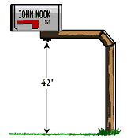 | 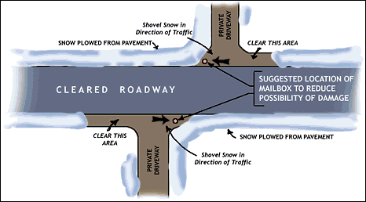
- Above right you will find a sketch showing the recommended location for your mailbox. Placing the mailbox on the side of your driveway away from approaching traffic will allow our driver to properly clear the roadway and to get as close as possible to your mailbox to minimize the amount of shoveling you will have to do to clear the mailbox for the postal carrier.
- For uncurbed roadways set the face of the mailbox back at least 12 inches from the edge of the paved surface of the road to provide the maximum possible roadway clearance. For curbed roads the face of the mailbox should be 8-12 inches back from the curb face.

Your participation and cooperation in complying with the above will be greatly appreciated by your rural carrier, postal service and Freeport Public Works Department.

In the event your mailbox is damaged by the Town plow we ask you to make any needed temporary repairs. If you are unable to make such repairs on your own please call Public Works at 865-4461 and upon availability, we will provide you with a temporary mailbox until the time at which you are able to repair or replace your mailbox. Newspaper boxes will not be repaired or reset by the Town in any event.

The Town will not replace or reimburse for custom made mailboxes, ornate posts or granite posts, etc., or existing mailboxes with rotted posts or in obvious poor existing condition. State of Maine law views mailboxes as an encroachment in the public right of way put there at the Owner's risk and municipalities are not legally liable for any damage or repairs to mailboxes due to plowing operations.

