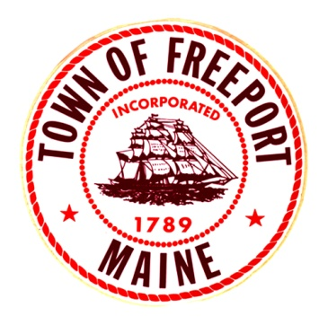
Town of Freeport Maine
Cable Department
30 Main Street
Freeport ME 04032 207-865-4743 x114 fctv3@freeportmaine.com

FIRE TV USER INSTRUCTIONS

Installing the FCTV3 App on Amazon Fire TV
You may install the FCTV3 Live Stream app 2 different ways:
- Using the remote for your Fire TV device
— OR —
- Using your Amazon account on the Amazon website
Using the Fire TV Stick Remote:
- From the Home screen, find the “Magnifying Glass” and search for Screenweave, the service that FCTV3 uses to stream our broadcast channel
- Select the Screenweave app
It should now be selected in the list of apps
- Click the Select button in the center of the circle of navigation keys
this will select the Screenweave app
- Choose “Get” to download the app
It will show “Queued” and then “Installing…”
You will also get an email to your amazon account acknowledging the order
Select “Open” to launch the app, or return to the home screen
- Once the app is installed, it will appear on the home screen on your device1
Installing the FCTV3 Live Stream Using the Amazon website
- Go to Amazon.com/appstore and log in with your Amazon account
- Search for “Screenweave”
- Click on the Screenweave app tile
- On the right side of the screen you should see “Deliver to: and confirm your device is selected
Below it is the “Get App” button
Click “Get App” and it will be sent to your Fire TV device
- It will soon appear on the home screen on your Fire TV device
Viewing the FCTV3 stream
- From the Fire TV device home screen, use the navigation buttons
- Click the “Down” button to highlight the Screenweave app
- Press the Select button to open Screenweave
- Select “Freeport TV3/FCTV3” from the list
- Select “Live Stream”
- Select “Watch Now” to view FCTV3’s live stream
- To watch FCTV3 from the Amazon Fire home screen, select Screenweave

